

**Enhanced Grammatical Framework Minibar**

**User Manual by**   
Dean Kopping | Modjadji Francis | Cassandra Tshabalala

**Version**

1.0.0

**Table of Contents**

1. Introduction 2

1.1. Overview 3

2. Getting Started 3

2.1. Cautions and Warning 3

2.2. Set up considerations? 3

2.3. User Access Considerations 4

3. Using the minibar 4

3.1 Uploading a grammar file 4

3.2 Changing translating settings 4

3.3 Translating a single sentence 5

3.4 Translating multiple sentences 6

3.5 Clearing selections 7

3.6 Random Sentence Generation 7

4. Troubleshoot and support 7

4.1. Sentence not being translated 7

4.2. Support 7

1. **Introduction**

Grammatical Framework is a programming language used for multilingual grammar applications. The framework has many uses, some of which include building translation systems, multilingual web gadgets, natural-language interfaces, and dialogue systems. The cloud-based editor: Grammatical Framework Minibar is one of the implementations of the grammatical framework. It was an implementation of Fridge Poetry, a GF web application, developed by Hallgreen, Enache and Ranta. The enhanced grammatical framework minibar is an improved version of the existing cloud-based editor.

This User Manual (UM) provides the information necessary for students/researchers interested in Grammatical Frameworks, individuals who would like to translate text using their own controlled natural language grammars and people interested in learning different languages to effectively use the Enhanced Grammatical Framework Minibar. It is a guide on the use and functionality of the desktop application. The Contents section, provide a reference to the page of each major functionalities and the sub chapters within. By clicking on the content title (online version), the reader is re-directed to the position of the content title.

* 1. **Overview**

The cloud-based editor is a tool that is used for translating …. It is a system that is built to work offline and provide translation services without access to the internet. The features and functionalities of the system include:

1. **The ability to upload their own grammar files:** Users of the enhanced system can upload their own grammar files to use when authoring text.
2. **Translate multiple sentences:** The user can translate multiple sentences at a time (i.e., the ability to translate paragraphs)
3. **Easy deletion of words:** The user has a simpler way of deleting words in the textbox instead of relying on the provided deletion buttons. Additionally, with the third feature being incorporated, this requirement expands to allowing easy deletion for all sentences in the case of translating multiple sentences.
4. **Predictive typing:** The user’s historical information is to be used for predictive typing. This means that as a user input their phrase in the minibar, the suggested next words need to be ordered based on the user’s history with the most recently used words being ordered first.

The basic UI of the system is shown below

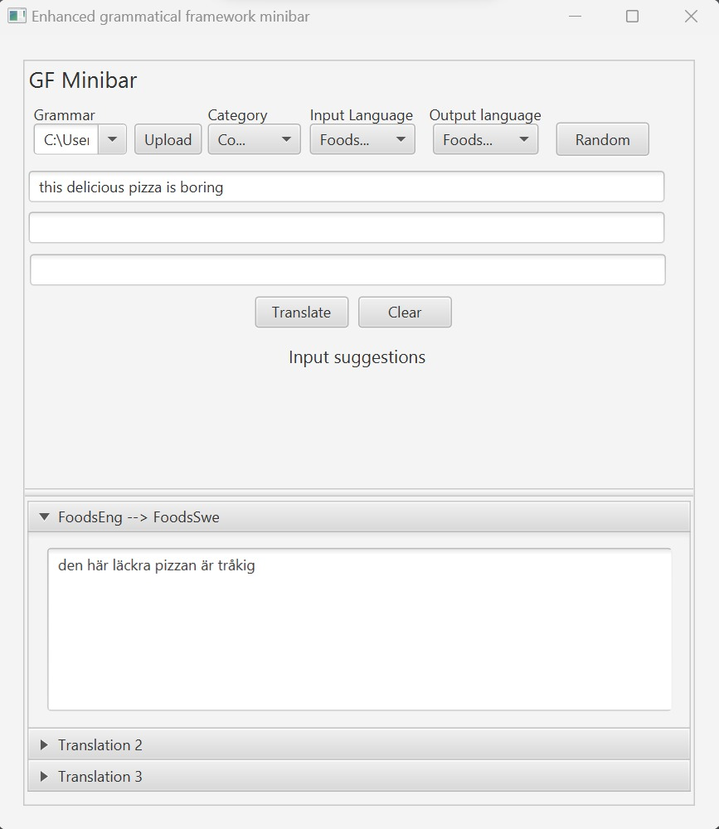

# **Getting Started**

## **Cautions and Warning**

Caching: the application does not store any files/information that had been used in a single session. Once the desktop app is exited, all information used in the session is lost. User will have to re-upload file if they wish to use the application again with the same grammar file.

## **Set up considerations?**

The enhanced GF Minibar is an offline desktop application. Ensure that you have the following to use the application:

## **User Access Considerations**

GF Minibar is a desktop application that makes use of .pgf to translate sentences. User will not be able to translate using a file of different extension. If the user is using a gf file, they need to compile it into a .pgf file using the following link:

# **Using the minibar**

## **3.1 Uploading a grammar file**

For the user to translate a body of text, they need to upload a grammar file that the application will use as a reference. In the app menu bar, click the “Upload” button for the app to access your desktop file system. A file selection panel will appear.

Once you have selected the file you wish to use, the file will be uploaded and the words in the file will appear.

## **3.2 Changing translating settings**

Once the file has been uploaded, user may want to change the language settings. To change the source language, select the “Input Language” to change the language the input sentence will be typed inand a drop-down menu of all languages associated with the grammar file will appear

Select the language you wish to translate to and do the same for the “Output Language” to select the language you wish the sentence to be translated to.

The user has the option to select “All” in which the sentence they input will be translated into all the languages that are supported by the grammar file

## **3.3 Translating a single sentence**

To translate a sentence, user clicks on the input textbox. Suggested words associated with the language and category selected will appear. The words that appear can be selected for input.

Type in a word/sentence. While typing, suggested words may appear

The translations will appear automatically in the collapsible panel when the full sentence is detected, or the user selects the translate button.

## **3.4 Translating multiple sentences**

This works like translating a single sentence. User can input at most 3 sentences to upload at the same. To translate all three sentences, user clicks on each input box and types in a single sentence.

The user then selects translate and the translations appear in the corresponding panels.

To view the translation of just a single sentence, user can expand/collapse the translations panels. By clicking on the translation panel.

## **3.5 Clearing selections**

The user has the option to clear their current input. To do this, user clicks on the “Clear” button, and this prompts the app to clear all input boxes and translation panels.

## **3.6 Random Sentence Generation**

To generate a randomly translated sentence, user must click the “Random” button, and this will prompt the web app to generate a random sentence which will appear in the relevant text field. The user must then select the translate button to complete the translation.

# **Troubleshoot and support**

## **Sentence not being translated**

Each pgf file contains a set of words that can be translated. As such there are certain sentences that may not be translated when the user either:

* + - Uses a word that the pgf does not contain,
    - Attempts to translate an incomplete sentence

Steps to follow when this happens:

* + - Try to restructure sentence to contain words that are in the pgf file.
    - Make sure that the correct grammar file has been uploaded (see *uploading grammar file*)
    - Make sure that the correct category has been selected (*see changing translations settings*)
  1. **Support**

To learn more about how the grammatical framework works follow the link:

<https://www.grammaticalframework.org/>

Please contact the following people for any additional questions about the use of the application.

|  |  |  |  |
| --- | --- | --- | --- |
| **Contact** | **Organization** | **Email** | **Role** |
| Dean Kopping | University of Cape Town | kppdea001@myuct.ac.za | Developer |
| Modjadji Francis | University of Cape Town | frnmod001@myuct.ac.za | Developer |
| Cassandra Tshabalala | University of Cape Town | tshcas005@myuct.ac.za | Developer |